**Lab 1 – Amazon EMR Console**

login as: ec2-user

In Amazon console, set up Jar (max-temperature.jar) and then set up arguments:

MaxTemperature

s3://chapter2/input

s3://chapter2/output

Run the max-temperature.jar in the EMR Console. Attach the screenshots of (1). your input file, (2). your steps in EMR, (3). your output file and (4). the content of your output file in this word document. Submit the word document to the blackboard.

**Screenshot_1**

**Screenshot_2**

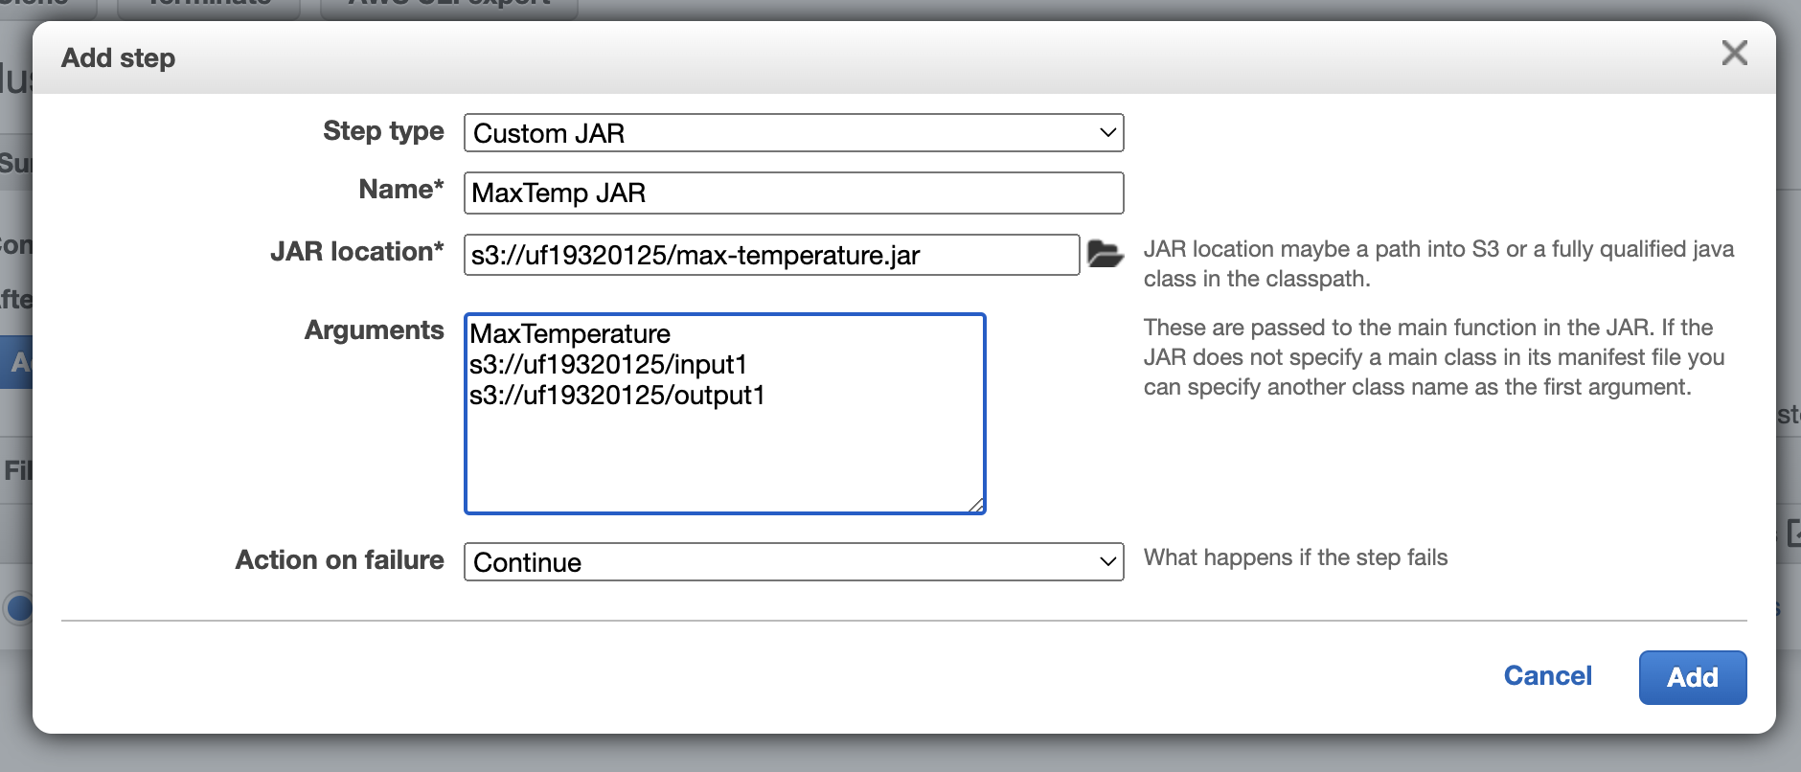

**Screenshot_3**

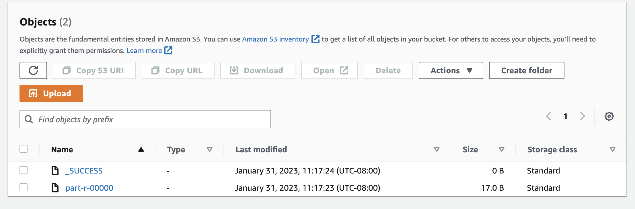

**Screenshot_4**

